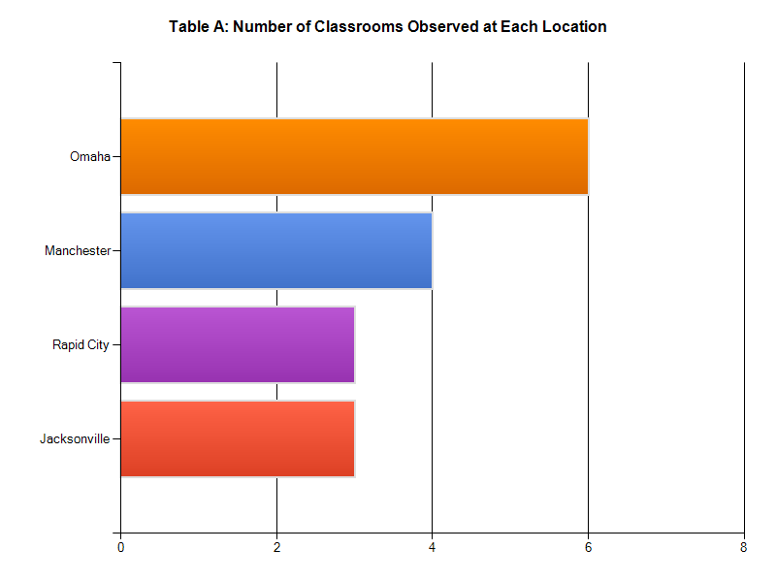In early October, Gibson and Associates conducted site observations of each GIRLSmart Program affiliate around the nation. G&A visited four affiliate locations: Rapid City, South Dakota, Omaha, Nebraska, Jacksonville, Florida, and Manchester, New Hampshire. Jean Simpson, representing the GIRLSmart Program staff, joined the G&A associates at all locations.

*Table A* shows the number of classrooms at each site for each location where observations were completed. A total of 16 classrooms were observed across multiple sites at the locations.

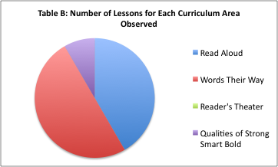At each affiliate, an associate observed each group leader on staff in his or her classroom. Each group leader was observed teaching a literacy lesson, and observations lasted an average of 40 minutes. Gibson and Associates collected information using a checklist of characteristics developed from the GIRLSmart curriculum in the program guide. Each kept a running record of group leader and student actions throughout the lesson.

*Table B* shows the breakdown of lessons observed from each of the four main areas of the GIRLSmart curriculum. In the 16 classrooms, 10 read aloud lessons, 12 Words Their Way lessons, and 2 Qualities of Strong Smart Bold lessons were observed. No Reader’s Theater lessons were observed.

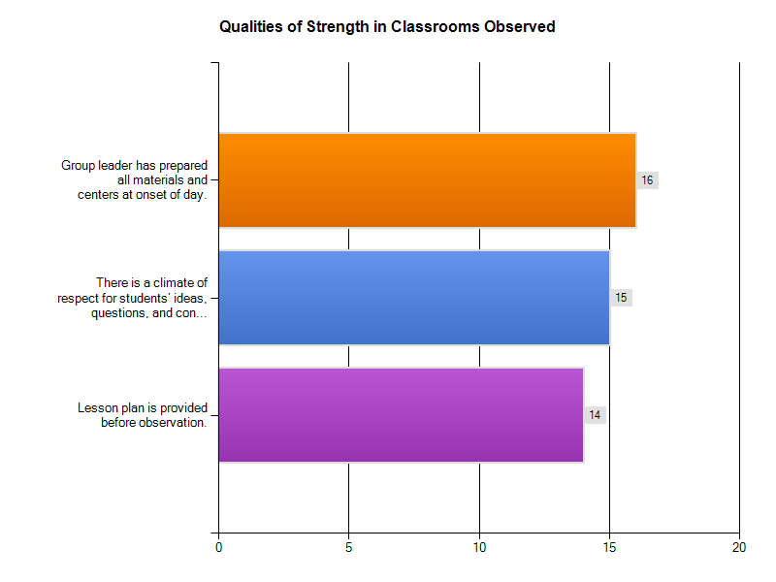**Overall Strengths:**

Table C shows the number of classrooms in which positive qualities of strong teaching occurred. GIRLSmart group leaders are particularly strong in the following two qualities:

1. Lesson planning and preparing for teaching is clearly evident.

2. Classroom management is positive.

“Researchers agree that students (particularly students from poverty) must feel safe in the classroom. If that doesn’t occur, then it is extremely difficult for students to learn.” (Prior, 2010).

**Top Opportunity for Improvement:**

Across all affiliates, there did not appear to be a consistent methodology for incorporating qualities for Strong Smart and Bold (SSB). These qualities were authentically incorporated into the lesson objective in only 20% of read aloud lessons and 25% of Words Their Way lessons.

Group Leaders need to understand and practice integrating qualities of strong smart bold into the curriculum in a meaningful way. For example, every book selected for class should highlight a quality and provide girls an opportunity to see the quality in action so they can begin to connect not only the character’s experience with their own life, but the quality as well. When possible, group leaders should make connections between vocabulary patterns in Words Their Way and SSB. In addition, as a classroom management tool, group leaders might emphasize how students are ‘caught’ exhibiting a SSB quality.

**Recommendations:**

* Create opportunities for cross-affiliate professional development. These opportunities would include discussing classroom experiences, seeking and giving advice to address specific areas for improvement, and sharing best practices and successful lessons.
* Focus efforts on clearer implementation of all four areas of curriculum.
* Share lesson design across affiliates for read aloud and readers theater lessons.
* Create simplified and sustainable processes for classroom protocols and procedures, particularly for implementing Words Their Way.

**Rapid City, South Dakota:**

This is a brief summary of our visit on October 3, 2011. Three lessons were observed at one site: All three lessons included read alouds and Words Their Way.

**Strengths:**

* Evidence of structured lesson planning.
* In all lessons, dynamic reading during read aloud.
* In all lessons, group leaders asked questions requiring more than just factual recall.
* Some evidence of modeling of comprehension techniques during read aloud.
* Excellent artifacts to support lesson.

Total of 3 lessons observed in 2 separate classrooms

* In 3 out of 3 lessons observed,

**Opportunities for Improvement:**

* In 3 out of 3 lessons observed, group leaders modeled the “asking questions” comprehension strategy. In 1 out of 3 lessons observed, students were actively using any of the 4 comprehension strategies.
* In 1 out of 3 lessons observed, group leaders appeared to engage all students using specific partner or group engagement techniques.
* In 1 out of 3 lessons observed, group leaders appeared to have consistent rules and procedures set up, as well as a positive behavior management system.

**Recommendations:**

* Learn about techniques to engage students: Think-Pair-Share, Structured question-sentence frame answers to be used during whole class instruction.
* Establish consistent procedures program wide for daily activities including entering classroom.
* Consider some positive reinforcement classroom management policy program wide. Seating and grouping arrangements for classroom management.
* Continue to review the program guide for ongoing education on the curriculum components, particularly the integration of Qualities of Strong, Smart, Bold into lessons, and requirements of program surrounding size and structure.

**Omaha, Nebraska:**

This is a brief summary of our visit on October 4 – 5, 2011. Six lessons were observed at 2 sites: three lessons were read alouds, two lessons were Words Their Way.

**Strengths:**

* Evidence of strong classroom management, organization and procedures in most lessons.
* Evidence of structured lesson planning in some lessons.
* Some evidence of high academic expectations.
* In all read-aloud lessons, group leaders introduced selection using a text-life connection, or had students make predictions about the book.

**Opportunities for Improvement:**

* In some read aloud lessons, pacing and dynamics need more focus.
* Provide students with enough processing time after a question is asked, then follow through with getting responses
* Give students more opportunities to share own experiences, reactions, reflections and answers to questions through use of think-pair-share, group response strategies (thumbs up-down), and show and tell a partner.
* Checking for student understanding during the Words Their Way independent sorting activity was limited to one-on-one assistance. Teachers did not use group or partner strategies for checking for understanding.

**Recommendations:**

* When the lessons fit the curriculum guidelines, they were well-planned, high engagement, and of high academic expectations for the students. When they deviated, they were less academically rigorous and focused.
* Review program guide and curriculum materials for further understanding of program requirements and structure, particularly curriculum guidelines
  + A Quality of SSB, Cool Words and a reading comprehension strategy should be integrated into all read aloud lesson plans.
  + When applicable WTW lessons should be related in some way to a quality of SSB, read-aloud book, or reader’s theater selection.

**Jacksonville, Florida:**

This is a brief summary of our visit on October 9 - 10, 2011. Four lessons were observed at 2 sites: All four lessons were Words Their Way.

**Strengths:**

* Evidence of structured lesson planning. All Lesson plans were all provided before observation.
* All group leaders had prepared all materials.
* Some evidence of group leaders using partner or group strategies.
* Evidence in most classrooms of very strong classroom management skills.
* Disruptions were addressed positively in all classrooms.
* Some evidence that group leaders are asking higher-level questions and using questioning strategies that engage student learning.

**Opportunities for Improvement:**

* Qualities of SSB were not being integrated into lesson plans or classroom culture.
* Group leaders did not use visuals to reinforce key vocabulary.
* Students were not grouped based on developmental or academic levels.
* Some teachers struggled with scaffolding the sorting activity to meet needs of multiple reading levels.
* There is a need to provide more explicit modeling of the Words Their Way sorting activities.
* Checking for student understanding during the independent sorting activity was limited to one-on-one assistance. Teachers did not use group or partner strategies for checking for understanding.

**Recommendations:**

* A structured peer observation cycle would support all group leaders with instructional strategies.
* Videotaping lessons followed by structured in-serve would also help with building internal capacity.
* Specific in-service/PD topics should include: engagement strategies, checking for understanding, scaffolding lessons, and higher order questioning.

**Manchester, New Hampshire:**

This is a brief summary of our visit on October 11 - 12, 2011. Four lessons were observed at 4 sites: All four lessons included read alouds, and three included Words Their Way.

**Strengths:**

* Evidence of structured lesson planning. All Lesson plans were all provided before observation.
* All group leaders had prepared all materials.
* Evidence of group leaders using partner or group strategies in all the classrooms.
* In all read aloud lessons, group leaders modeled and students used the making connections comprehension strategy.
* During all read aloud lessons, group leaders would pause to allow students to ask questions, as well as ask questions of the students requiring more than factual recall.

**Opportunities for Improvement:**

* Words Their Way lessons could be extended and enriched with more activities, and integrated with the other areas of the curriculum.
* Qualities of SSB were not being integrated into lesson plan or classroom culture.
* Read aloud activities should include authentic student work with high academic expectations.

**Recommendations:**

* Review program guide and curriculum materials for further understanding of program requirements and structure, particularly curriculum guidelines
  + A Quality of SSB, Cool Words and a reading comprehension strategy should be integrated into all read aloud lesson plans.
  + When applicable WTW lessons should be related in some way to a quality of SSB, read-aloud book, or reader’s theater selection.
* A structured peer observation cycle would support all group leaders with instructional strategies.